## Practice 5-1: Using Conversion Functions and Conditional Expressions

Unauthorized reproduction or distribution prohibitedฺ Copyright 2012, Oracle and/or its affiliatesฺ

##### Overview

This practice provides a variety of exercises using the TO_CHAR and TO_DATE functions, and conditional expressions such as CASE, searched CASE, and DECODE.

##### Tasks

1. Create a report that produces the following for each employee:

<employee last name> earns <salary> monthly but wants <3 times salary.>. Label the column Dream Salaries.

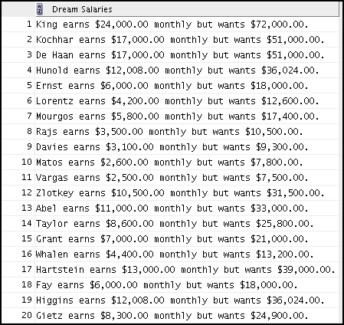

1. Display each employee’s last name, hire date, and salary review date, which is the first Monday after six months of service. Label the column REVIEW. Format the dates to appear in a format that is similar to “Monday, the Thirty-First of July, 2000.”

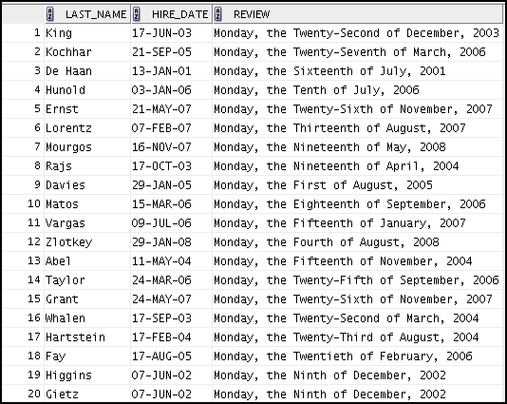

1. 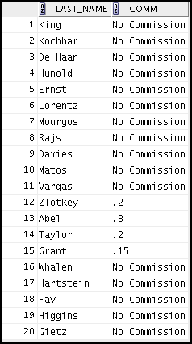Create a query that displays employees’ last names and commission amounts. If an employee does not earn commission, show “No Commission.” Label the column COMM.
2. Using the CASE function, write a query that displays the grade of all employees based on the value of the JOB_ID column, using the following data:

Unauthorized reproduction or distribution prohibitedฺ Copyright 2012, Oracle and/or its affiliatesฺ

###### Job Grade

AD_PRES A

ST_MAN B

IT_PROG C

SA_REP D

ST_CLERK E

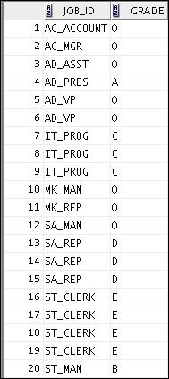None of the above 0

1. 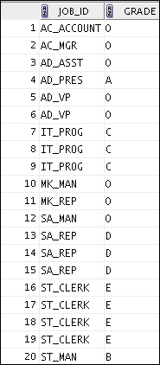Rewrite the statement in the preceding exercise by using the searched CASE syntax.
2. Rewrite the statement in the preceding exercise by using the searched DECODE syntax.

Unauthorized reproduction or distribution prohibitedฺ Copyright 2012, Oracle and/or its affiliatesฺ



## Practice 6-1: Reporting Aggregated Data by Using Group Functions

Unauthorized reproduction or distribution prohibitedฺ Copyright 2012, Oracle and/or its affiliatesฺ

##### Overview

After completing this practice, you should be familiar with using the group functions and selecting groups of data.

##### Tasks

Determine the validity of the following statements. Circle either True or False.

1. Group functions work across many rows to produce one result per group. True/False
2. Group functions include nulls in calculations. True/False
3. The WHERE clause restricts rows before inclusion in a group calculation. True/False

The HR department needs the following reports:

1. Find the highest, lowest, sum, and average salary of all employees. Label the columns Maximum, Minimum, Sum, and Average, respectively. Round your results to the nearest whole number. Save your SQL statement as lab_06_04.sql. Run the query.



1. Modify the query in lab_06_04.sql to display the minimum, maximum, sum, and average salary for each job type. Save lab_06_04.sql as lab_06_05.sql again. Run the statement in lab_06_05.sql.

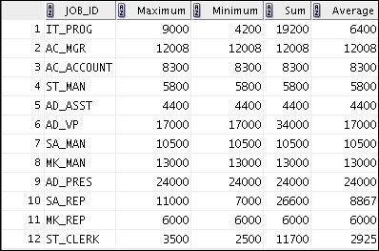

1. 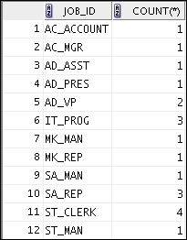Write a query to display the number of people with the same job.

Unauthorized reproduction or distribution prohibitedฺ Copyright 2012, Oracle and/or its affiliatesฺ

Generalize the query so that the user in the HR department is prompted for a job title. Save the script to a file named lab_06_06.sql. Run the query. Enter IT_PROG when prompted.



1. Determine the number of managers without listing them. Label the column Number of Managers.

**Hint:** Use the MANAGER_ID column to determine the number of managers.

1. Find the difference between the highest and lowest salaries. Label the column

DIFFERENCE.

If you have time, complete the following exercises:

1. Create a report to display the manager number and the salary of the lowest-paid employee for that manager. Exclude anyone whose manager is not known. Exclude any groups where the minimum salary is $6,000 or less. Sort the output in descending order of salary.

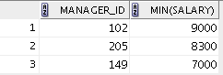

If you want an extra challenge, complete the following exercises:

Unauthorized reproduction or distribution prohibitedฺ Copyright 2012, Oracle and/or its affiliatesฺ

1. Create a query to display the total number of employees and, of that total, the number of employees hired in 2005, 2006, 2007, and 2008. Create appropriate column headings.
2. Create a matrix query to display the job, the salary for that job based on the department number, and the total salary for that job, for departments 20, 50, 80, and 90, giving each column an appropriate heading.

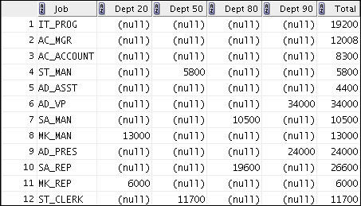

## Practice 7-1: Displaying Data from Multiple Tables by Using Joins

Unauthorized reproduction or distribution prohibitedฺ Copyright 2012, Oracle and/or its affiliatesฺ

##### Overview

This practice is intended to give you experience in extracting data from multiple tables using the SQL:1999–compliant joins.

##### Tasks

1. 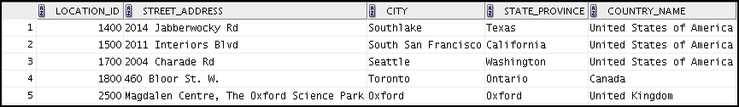Write a query for the HR department to produce the addresses of all the departments. Use the LOCATIONS and COUNTRIES tables. Show the location ID, street address, city, state or province, and country in the output. Use a NATURAL JOIN to produce the results.
2. The HR department needs a report of all employees with corresponding departments. Write a query to display the last name, department number, and department name for these employees.

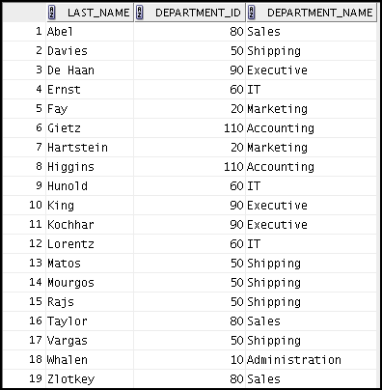

1. 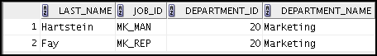The HR department needs a report of employees in Toronto. Display the last name, job, department number, and the department name for all employees who work in Toronto.

Unauthorized reproduction or distribution prohibitedฺ Copyright 2012, Oracle and/or its affiliatesฺ

1. 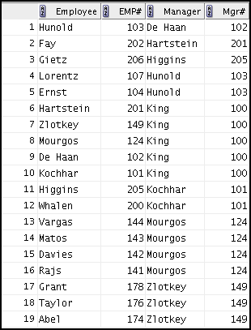Create a report to display employees’ last names and employee numbers along with their managers’ last names and manager numbers. Label the columns Employee, Emp#, Manager, and Mgr#, respectively. Save your SQL statement as lab_07_04.sql. Run the query.
2. 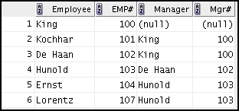Modify lab_07_04.sql to display all employees, including King, who has no manager. Order the results by employee number. Save your SQL statement as lab_07_05.sql. Run the query in lab_07_05.sql.

##### …

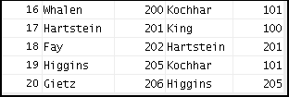

Unauthorized reproduction or distribution prohibitedฺ Copyright 2012, Oracle and/or its affiliatesฺ

1. 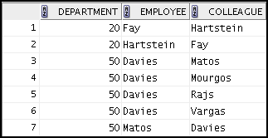Create a report for the HR department that displays employee last names, department numbers, and all the employees who work in the same department as a given employee. Give each column an appropriate label. Save the script to a file named lab_07_06.sql.

##### …

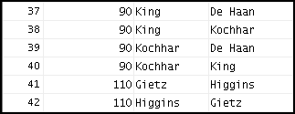

1. 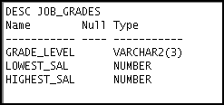The HR department needs a report on job grades and salaries. To familiarize yourself with the JOB_GRADES table, first show the structure of the JOB_GRADES table. Then create a query that displays the name, job, department name, salary, and grade for all employees.

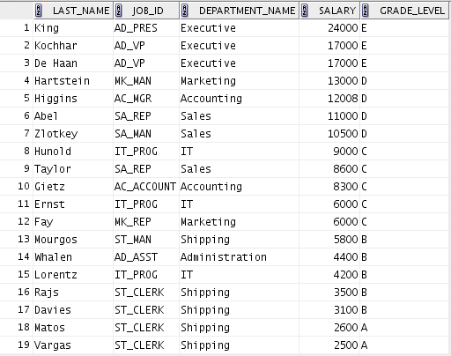

Unauthorized reproduction or distribution prohibitedฺ Copyright 2012, Oracle and/or its affiliatesฺ

If you want an extra challenge, complete the following exercises:

1. 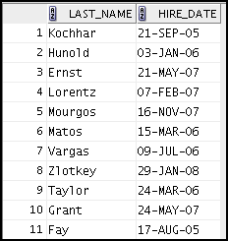The HR department wants to determine the names of all employees who were hired after Davies. Create a query to display the name and hire date of any employee hired after employee Davies.
2. 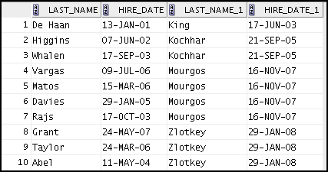The HR department needs to find the names and hire dates of all employees who were hired before their managers, along with their managers’ names and hire dates. Save the script to a file named lab_07_09.sql.

## Practice 8-1: Using Subqueries to Solve Queries

Unauthorized reproduction or distribution prohibitedฺ Copyright 2012, Oracle and/or its affiliatesฺ

##### Overview

In this practice, you write complex queries using nested SELECT statements.

For practice questions, you may want to create the inner query first. Make sure that it runs and produces the data that you anticipate before you code the outer query.

##### Tasks

1. 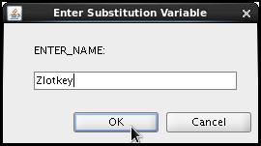The HR department needs a query that prompts the user for an employee’s last name. The query then displays the last name and hire date of any employee in the same department as the employee whose name the user supplies (excluding that employee). For example, if the user enters Zlotkey, find all employees who work with Zlotkey (excluding Zlotkey).

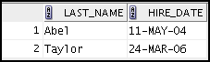

1. 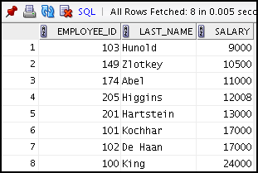Create a report that displays the employee number, last name, and salary of all employees who earn more than the average salary. Sort the results in ascending order by salary.
2. Write a query that displays the employee number and last name of all employees who work in a department with any employee whose last name contains the letter “u.” Save your SQL statement as lab_08_03.sql. Run your query.

Unauthorized reproduction or distribution prohibitedฺ Copyright 2012, Oracle and/or its affiliatesฺ

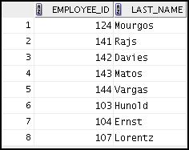

1. The HR department needs a report that displays the last name, department number, and job ID of all employees whose department location ID is 1700.

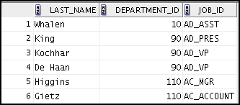

Modify the query so that the user is prompted for a location ID. Save this to a file named

lab_08_04.sql.

1. 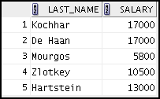Create a report for HR that displays the last name and salary of every employee who reports to King.
2. Create a report for HR that displays the department number, last name, and job ID for every employee in the Executive department.

Unauthorized reproduction or distribution prohibitedฺ Copyright 2012, Oracle and/or its affiliatesฺ

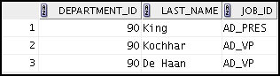

1. Create a report that displays a list of all employees whose salary is more than the salary of any employee from department 60.

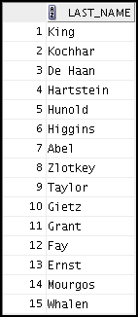

If you have time, complete the following exercise:

1. Modify the query in lab_08_03.sql to display the employee number, last name, and salary of all employees who earn more than the average salary, and who work in a department with any employee whose last name contains the letter “u.” Save lab_08_03.sql as lab_08_08.sql again. Run the statement in lab_08_08.sql.